
Lab Number: 2 Date:2025/06/13
Title: Understanding Ethernet Wiring in detail.

THEORY:

Network Equipment Details:
- RJ45 Connectors:
RJ45 stands for Registered Jack 45 and is the common connector used to link Ethernet cables to devices within a wired LAN network.
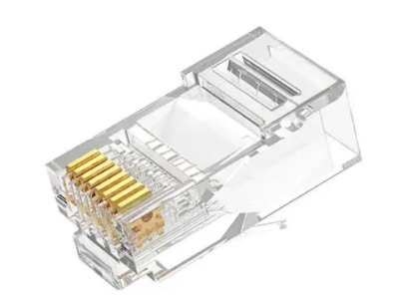

Fig : RJ45 Connectors

Crimping Tool:

A crimping tool is a handheld device that joins two metal pieces by compressing a connector, like a wire terminal, around a wire. This process forms a secure mechanical and electrical bond called a crimp.

Fig: Crimping Tool

Cable Tester:
A network cable tester is a device designed to test the wiring and connections of cables with RJ45 connectors, commonly used for Ethernet and LAN cables.
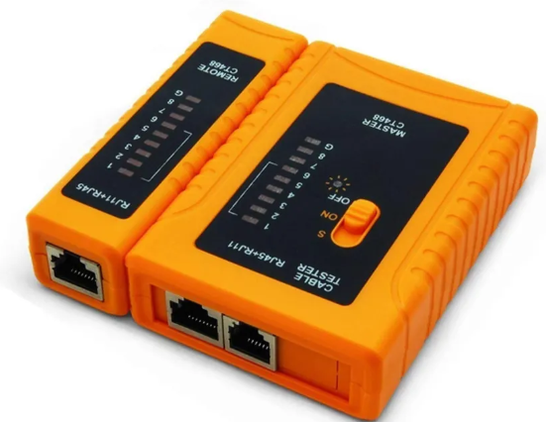
Fig: Cable Tester

UTP Cable :
UTP (Unshielded Twisted Pair) cables serve as the medium for data transmission in a LAN. Commonly used categories, such as Cat5e and Cat6, support Ethernet networks with data transfer speeds of up to 1 Gbps and 10 Gbps, respectively.
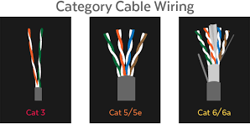
Fig: UTP Cables

Cable Stripper:
A wire stripper is a hand tool used to remove the insulation or protective coating from electrical wires, allowing the user to expose the metal conductor for connection or repair.

Fig: Cable Stripper

Wiring Details:
  - Straight-Through UTP Cable
A straight-through UTP (Unshielded Twisted Pair) cable is an Ethernet cable with identical wiring on both ends—pin 1 connects to pin 1, pin 2 to pin 2, and so forth—commonly used to connect different types of devices, like a computer to a switch or router.

T568B Color Code:

Pin 1 | White/Orange
Pin 2 | Orange
Pin 3 | White/Green
Pin 4 | Blue
Pin 5 | White/Blue
Pin 6 | Green
Pin 7 | White/Brown
Pin 8 | Brown

It can be represented as:

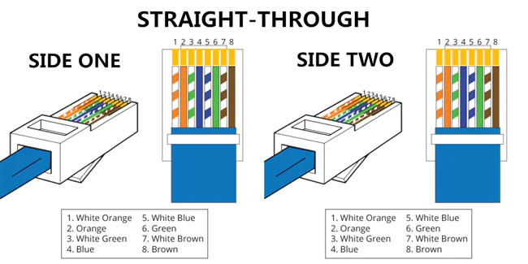
Fig : Straight through UTP Cable

Crossover UTP Cable:
Description: A straight-through UTP (Unshielded Twisted Pair) cable is typically used to connect different types of devices within a network, such as a computer to a switch or a router. One end of the cable follows the T568A standard, and the other end follows the T568B standard.

T568A Color Code:

Pin 1 | White/Green
Pin 2 | Green
Pin 3 | White/Orange
Pin 4 | Blue
Pin 5 | White/Blue
Pin 6 | Orange
Pin 7 | White/Brown
Pin 8 | Brown

T568B Color Code:

Pin 1 | White/Orange
Pin 2 | Orange
Pin 3 | White/Green
Pin 4 | Blue
Pin 5 | White/Blue
Pin 6 | Green
Pin 7 | White/Brown
Pin 8 | Brown

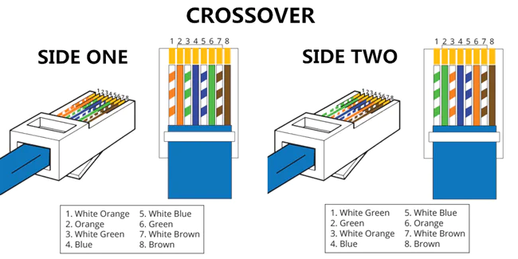
Fig : Crossover through UTP Cable

STEPS REQUIRED:

Algorithm for STRAIGHT-THROUGH:
1. Measure and cut the required length of UTP cable.
2. Strip about 1 inch of the outer jacket at one end.
3. Untwist and straighten the wire pairs.
4. Arrange wires in T568B color order.
5. Trim the wires evenly to the same length
6. Insert wires into the RJ-45 connector, ensuring the order is correct.
7. Crimp the connector using a crimping tool.
8. Repeat steps 2–7 for the other end of the cable using the same T568B wiring order.
9. Test the cable with a cable tester to confirm proper connections.

Algorithm for CROSSOVER:

1. Measure and cut the UTP cable to the desired length.

2. Strip about 1 inch of the outer jacket from one end of the cable.

3. Untwist and straighten the wire pairs.

4. Arrange wires in T568A order.

5. Trim the wires evenly and insert them into an RJ-45 connector.

6. Crimp the connector using a crimping tool.

7. Repeat steps 2–6 on the other end, but use T568B color order.

8. Test the cable using a cable tester to verify proper crossover configuration.

CONCLUSION:
In this lab, we learned how to create Ethernet cables by assembling both straight-through and crossover UTP wires. We used tools like crimping devices, RJ-45 connectors, and testers to complete and check our cables. By applying T568A and T568B wiring standards, we ensured correct connections. This practical exercise strengthened our basic skills for building dependable wired network setups.

